*  
  
  
Press Release 09/2022*

*Moers in September 2022*

# Press Release

### QuickCurtain: This is how fast...

*New Edscha TS "high-speed" side curtain*

**It is probably the "fastest side curtain" in the world. Opening or closing with the new QuickCurtain side curtain from Edscha TS is a small speed experience. Because one man can do it comfortably in about one minute. Wherever logisticians discuss new fast, time-saving and, above all, safe options for loading and unloading in the face of growing cargo volumes, the new QuickCurtain will be the talk of the town. QuickCurtain was presented at the IAA Transportation 2022 in Hannover.**

**When experience counts**

Edscha TS is one of the tarpaulin specialists with a very long experience in the development and construction of components for load-safe side curtains. New in this segment is now QuickCurtain, a very fast, simple and easy to use side curtain system. It is the beginning of a new generation of side curtain systems that will be demanded in the future.

**Precision makes fast**

You have to have ideas: QuickCurtain is a side curtain that runs on rollers both above and below. The rollers are guided by solid and very precisely manufactured segmented steel rails. And there is another special feature: during assembly, the usual approx. 20 dead center tensioners in the curtain and the separately operated stanchions are completely dispensed with. The vertical Kevlar tensioning belts incorporated between the curtain rollers and the roller rail also eliminate the need for all lateral insertion profiles. The system is designed for all standard applications and also with positive-locking loading according to EN12642 "XL" with verification by dynamic testing.

**No assembly problems**

During the entire assembly of the QuickCurtain system, the vertical tensioning tubes on the bulkhead and rear portal are retained. The same applies to the familiar roof straps (with SPR4 tarpaulin rollers) of the standard series. The system is supplemented by the new LP4 rolling stanchion and the lower rolling anchors on a curtain specially made by Edscha TS.

**Looking ahead**

The QuickCurtain is the side curtain of the future, which is already fully usable today. It is therefore aimed at the user who uses a normal side curtain, but still does not want to do without the advantages of a new future technology. The rail is segmented on the chassis for easy maintenance and designed to allow straps for load securing behind the QuickCurtain without impairing its function, even for winches under the frame.

**Robust and easy to service**

The main features of QuickCurtain include convenient one-man operation and very smooth and fast opening of the side curtain from the ground in about one minute. Speed and safety are not dependent on the load volume. In addition, the system is very robust and easy to service. And features integrated load securing. Plug-in boards do not have to be used.

**Can be installed in all standard CS vehicles**

QuickCurtain can be installed in all standard CS vehicles without major problems. Dead center tensioners can be safely forgotten. The segmented track is specially manufactured from high-quality flat steel to a high degree of precision and is designed for trouble-free maintenance.

**Tarpaulin included**

There is no interference with the installation space for clamping center support. Likewise, horizontal series clamping systems are retained by the CS structure for robust operation and favorable implementation. The package length is 25% of the length of the loading area. And another piece of good news from the QuickCurtain: the tarpaulin is part of the scope of delivery and can be labeled on request.

**Looks smart. And is "very quick”**

Even if there is little talk about the design of a canopy system: "QuickCurtain" also makes a perfect impression as a smooth and very large surface for e.g. advertising. And has really "quick properties". More on the website.

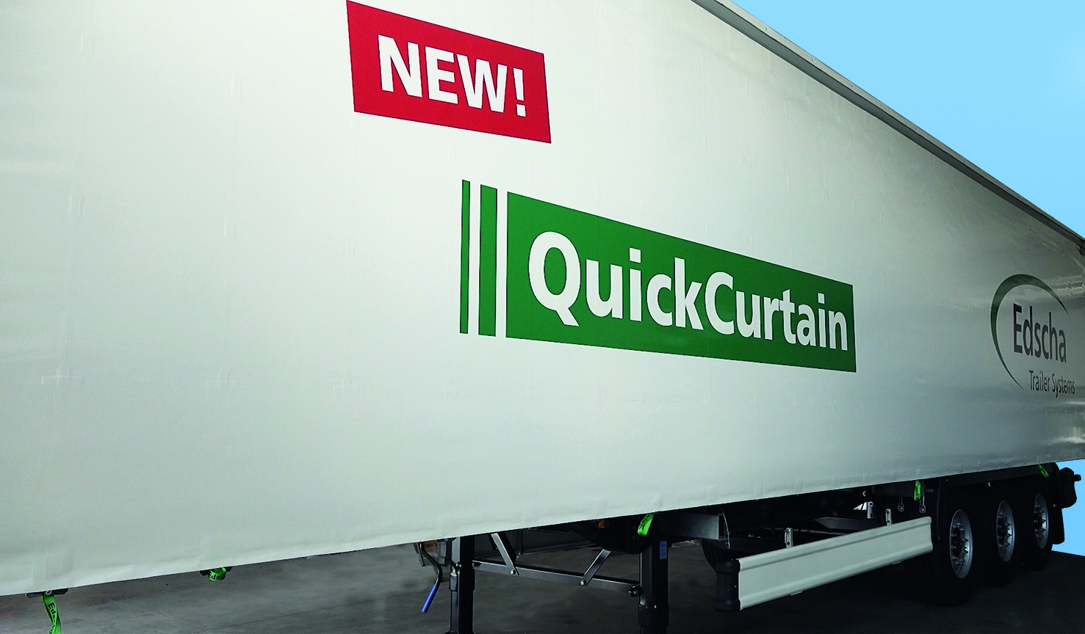  
The new QuickCurtain

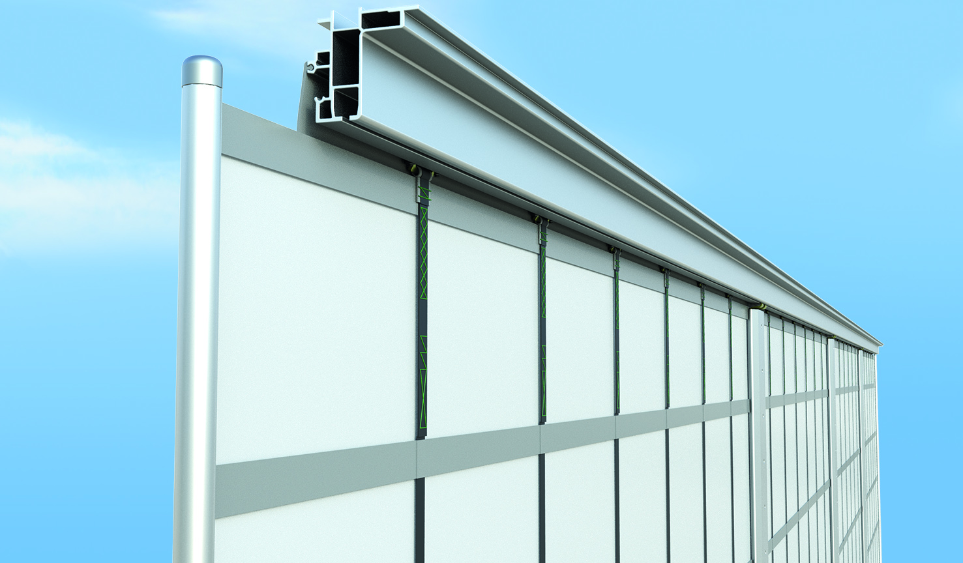  
QuickCurtain with profile

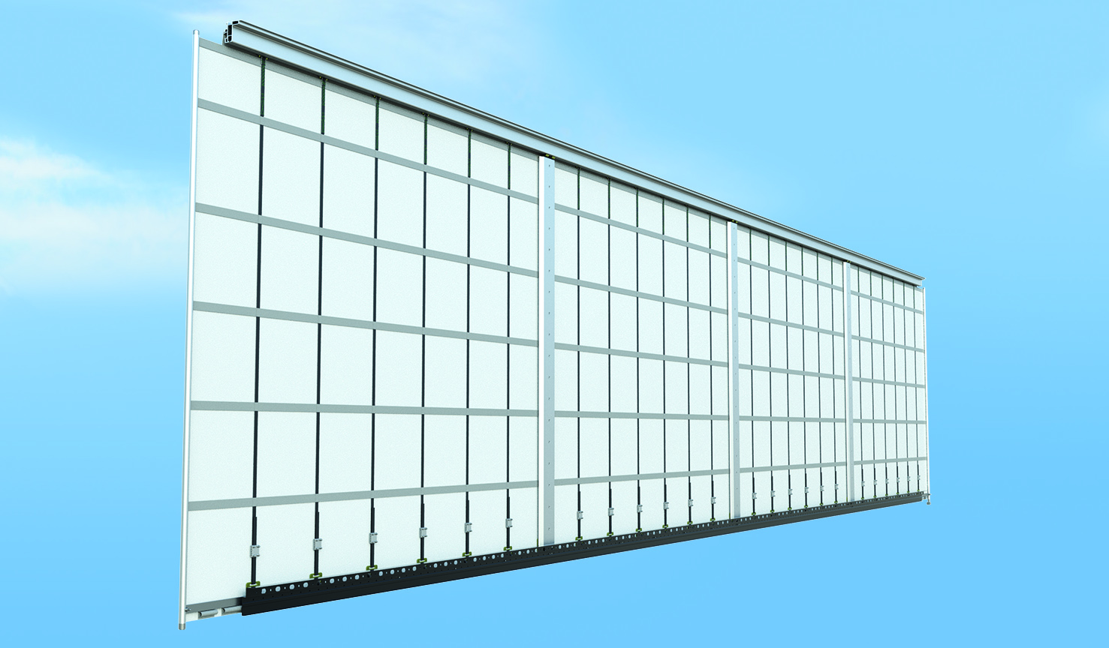  
QuickCurtain from the inside

**Contact Edscha Trailer Systems:**

Mr. Roger Remmel

Mail: [Marketing@EdschaTS.com](mailto:Marketing@EdschaTS.com)

www.EdschaTS.com Member of VBG GROUP