*  
  
  
Press Release 09/2022*

*Moers in September 2022*

# Press Release

### Sustainability and more!

*Edscha TS with new ideas for more sustainability*

**Can the topic of sustainability also be applied to convertible top systems in a very practical way? Edscha TS, inventor of the sliding roof and market leader in this segment, answers this question with an unequivocal YES. And presents four impressive examples of how sustainability can be implemented in the field of tarpaulin technology.**

**Sustainability and efficiency - not a contradiction!**

Edscha TS is a sustainable company with solutions for safe and efficient transportation throughout road and rail transport, industry and many other sectors. Sustainability goals in terms of climate, safety, people and society are implemented through the continuous optimization of Edscha TS products. Constant dialog with customers, permanent analysis of the value chain and new technological ideas as a basis for the high demands on our own actions make these goals realizable. This is the only way to come up with ideas that lead to even greater sustainability.

**PP fabric and coating**

The new roof tarpaulins from Edscha TS are made of PP and are 100% recyclable by type. Sustainable and optimized. In terms of quality and durability, there is no difference to the conventional PVC tarpaulin. The new tarpaulins are UV and chemical resistant. And as a special bonus, they are up to 40% lighter than PVC. Of course, they can be adapted to all CS tarpaulins. The tarpaulins can be supplied together with a tarpaulin kit and can be installed cost-effectively by the customer.

**No steel, but fabric tape**

More safety for individual applications and repairs is provided by the new roof stiffeners with universal lengths of fabric tape. The fabric tape is open at one end and can thus be easily adjusted as required. This roof bracing with clamping element is tried and tested and safe. Function and force transmission have remained constant compared to the version with steel cables. The product can therefore also be used in vehicles with certifiable Edscha TS-XL roof bracing.

**Service life of a tarpaulin**

Tarpaulin wear will also be noticeably reduced in the future thanks to further developed Profi assemblies and roof tarpaulin fasteners. This will also significantly improve the sealing of the tarpaulins. improved. The new technology also makes increased bounce absorption possible. Perfect for tough day-to-day logistics!

**Bows - screw on, screw off!**

As an option, the bows of the hybrid tarpaulins can now also be screwed on. Then the roller carriage bows can also be separated for repair and recycling and also replaced individually. The width can be adjusted in the process.

**Acting today for tomorrow**

Sustainability and the corporate future of Edscha TS, with regard to the further development of tarpaulin technologies, are key agenda items for the company. Especially against the background of the current climate and energy crisis, Edscha TS is well positioned. Other points such as the ongoing expansion of digitalization, better customer service and strong customer loyalty will be further growth factors in the future. Edscha TS convertible tops are a worthwhile investment for the future due to their high functionality in everyday practice as well as their long service life and reliability. Especially when it comes to sustainability.

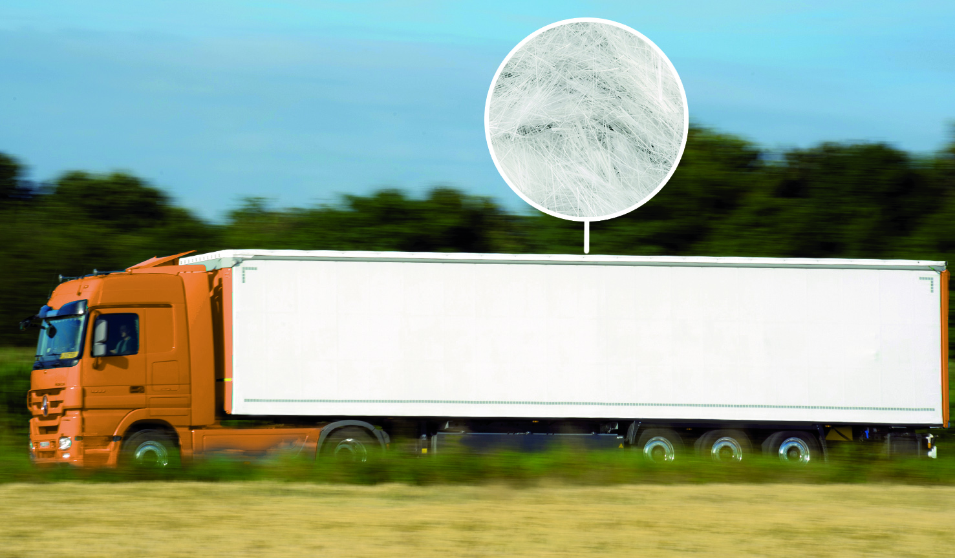  
Recycled PP roof tarpaulin

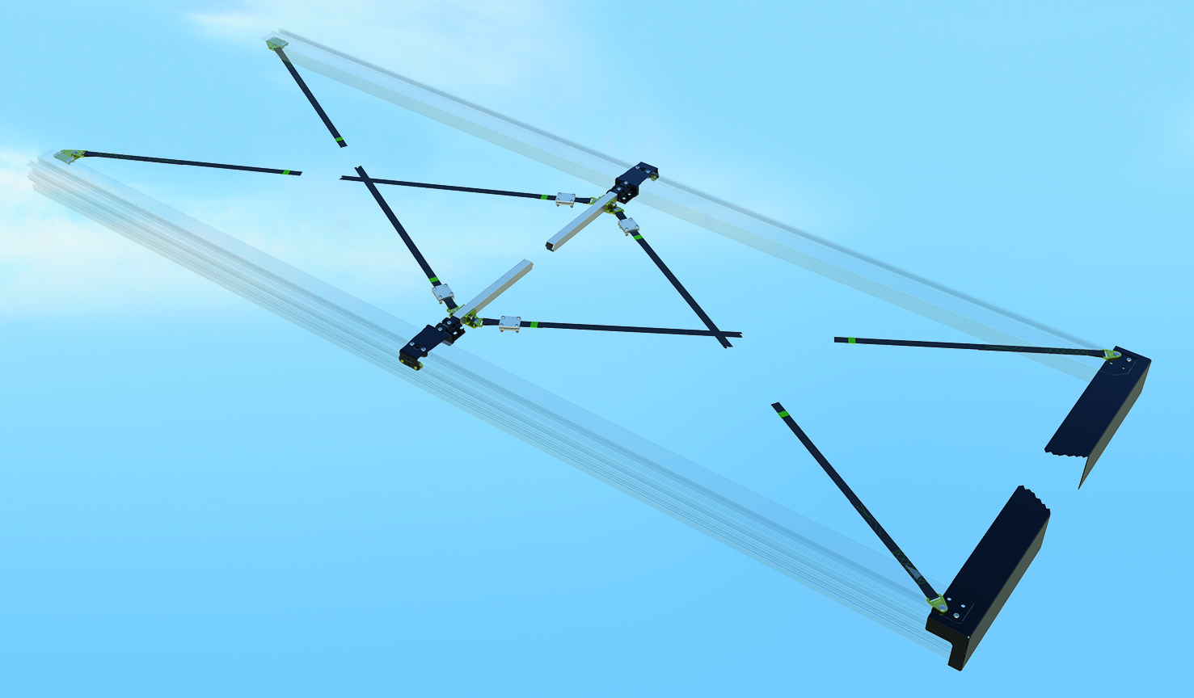  
Tensioning system with adjustable straps

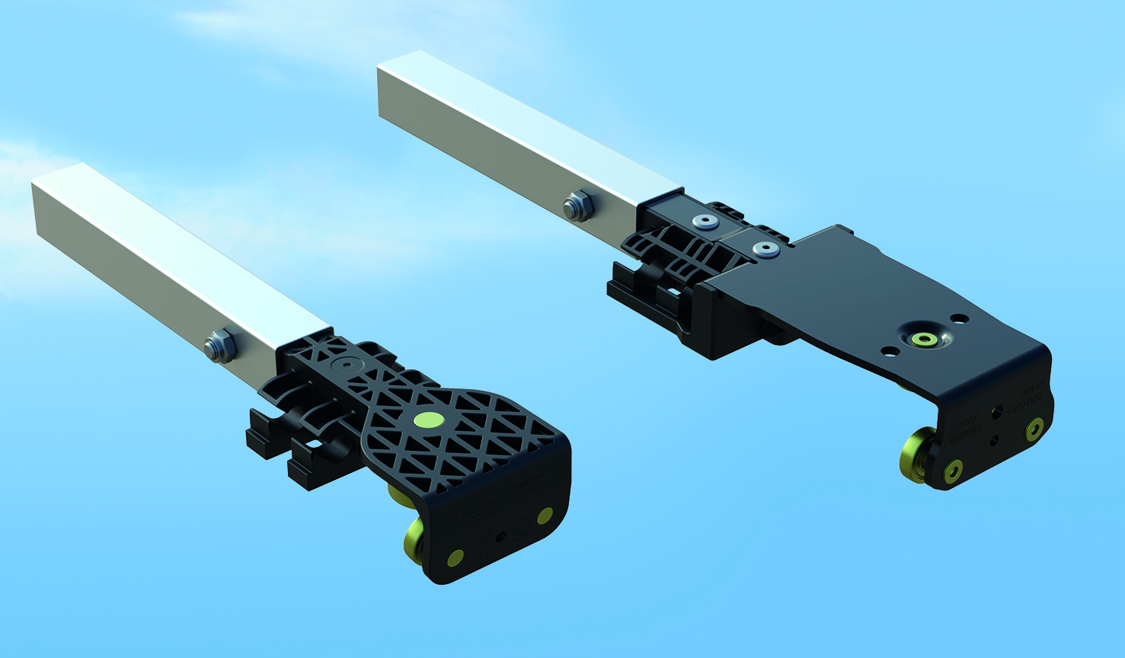  
Bolted bows CS/VP

**Contact Edscha Trailer Systems:**

Mr. Roger Remmel

Mail: [Marketing@EdschaTS.com](mailto:Marketing@EdschaTS.com)

www.EdschaTS.com Member of VBG GROUP